Echos of Aristocracy: Reviving the lost identity of Nagarpur Zamindar Bari through reconnection & renewal

Project brief:

Name of the Project:
Reviving the lost identity of Nagarpur Zaminder bari through community-integrated tourism conservation
Location of the Project:
Nagarpur upazila, Tangail
Site Area:
8.23 acres (358,738.35 sqft)
Type of Project:
Heritage conservation
Nature of the Project:
Conceptual
Client/Potential Client:
Department of Archaeology, Sher-e Bangla Nagar, Dhaka, Bangladesh. Main
Contact/Resource person:
Dwip Bhowmick (Nagarpur upazila executive officer)
Financing Authority:
• Department of Archaeology, Sher-e Bangla Nagar, Dhaka, Bangladesh
• Tangail PWD Division, Tangail
Implementing Authority:
Government
Supervisor:
Tamanna Sultana Swarna
Assistant Professor
Department of Architecture
Rajshahi University of Engineering & Technology
The Nagarpur Chowdhury Zamindar Bari, established by Jadunath Chowdhury on 54 acres of land, is a significant cultural and architectural landmark, reflecting European influences and symbolizing the Zamindari era's socio-economic practices. Despite its historical value, the Bari faces neglect and deterioration due to urbanization, socio-economic transitions, and changes in its functional use. By proposing a sustainable conservation strategy to protect and revive the site these issues can be solved. Focusing on adaptive reuse, the research aims to preserve Bari’s historical essence while integrating it into modern socio-economic contexts. A multidisciplinary methodology—encompassing historical research, architectural analysis, stakeholder interviews, and community engagement—forms the foundation of a comprehensive conservation framework. By evaluating the site’s historical significance, current condition, and adaptive reuse potential, the study proposes sustainable strategies for its preservation. The research seeks to restore the historical identity of the Zamindar Bari and promote its adaptive reuse as a hub for cultural heritage tourism. This approach aspires to generate national economic opportunities, foster local community engagement, and sustain the artistic essence of the Zamindari era. This dissertation highlights adaptive reuse as a strategic tool for conserving heritage within evolving urban landscapes, ensuring these treasures remain relevant for future generations. The restoration of Nagarpur Zamindar Bari can serve as a model for similar initiatives across Bangladesh, ensuring that the legacy of such sites continues to inspire and educate future generations.
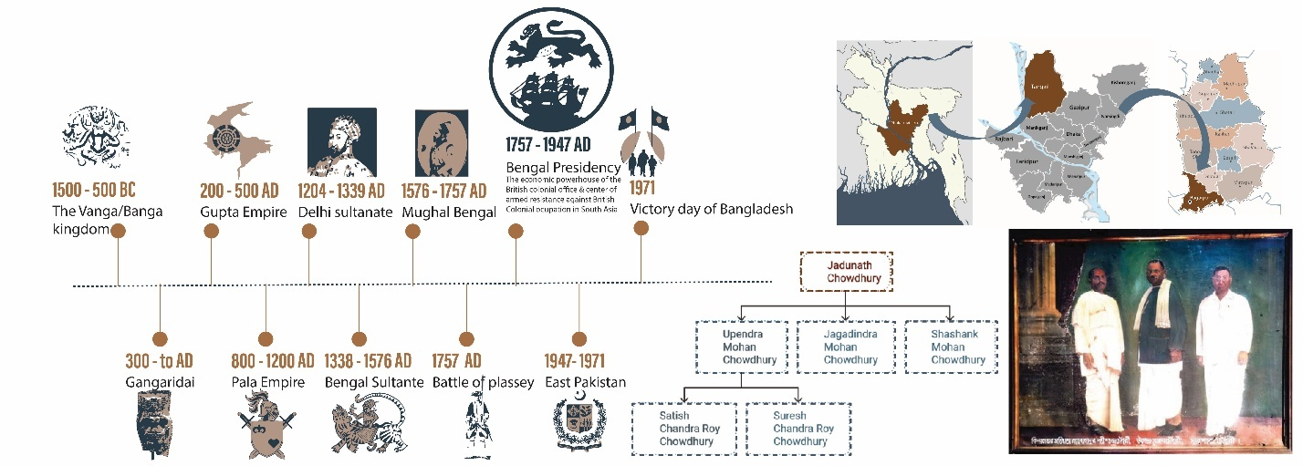
History & Background of the project
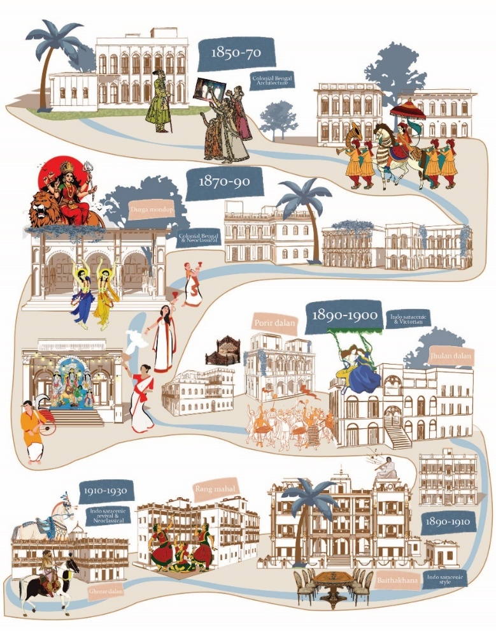
Chronology of Nagarpur Zamindar houses
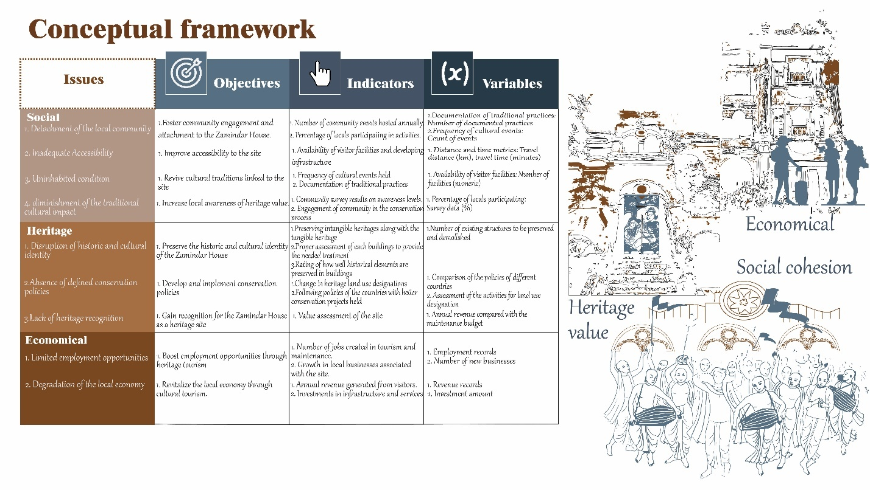
Issues, objectives and conceptual framework
Design concept
Balancing the TIMELESS TIES
The concept of "Balancing the Timeless Ties" aims to bridge the historical and emotional connection of Nagarpur Zamindar Bari with its community, while addressing contemporary needs without compromising the heritage’s authenticity. This approach revives the site’s lost identity by harmonizing conservation, adaptive reuse, and cultural engagement.

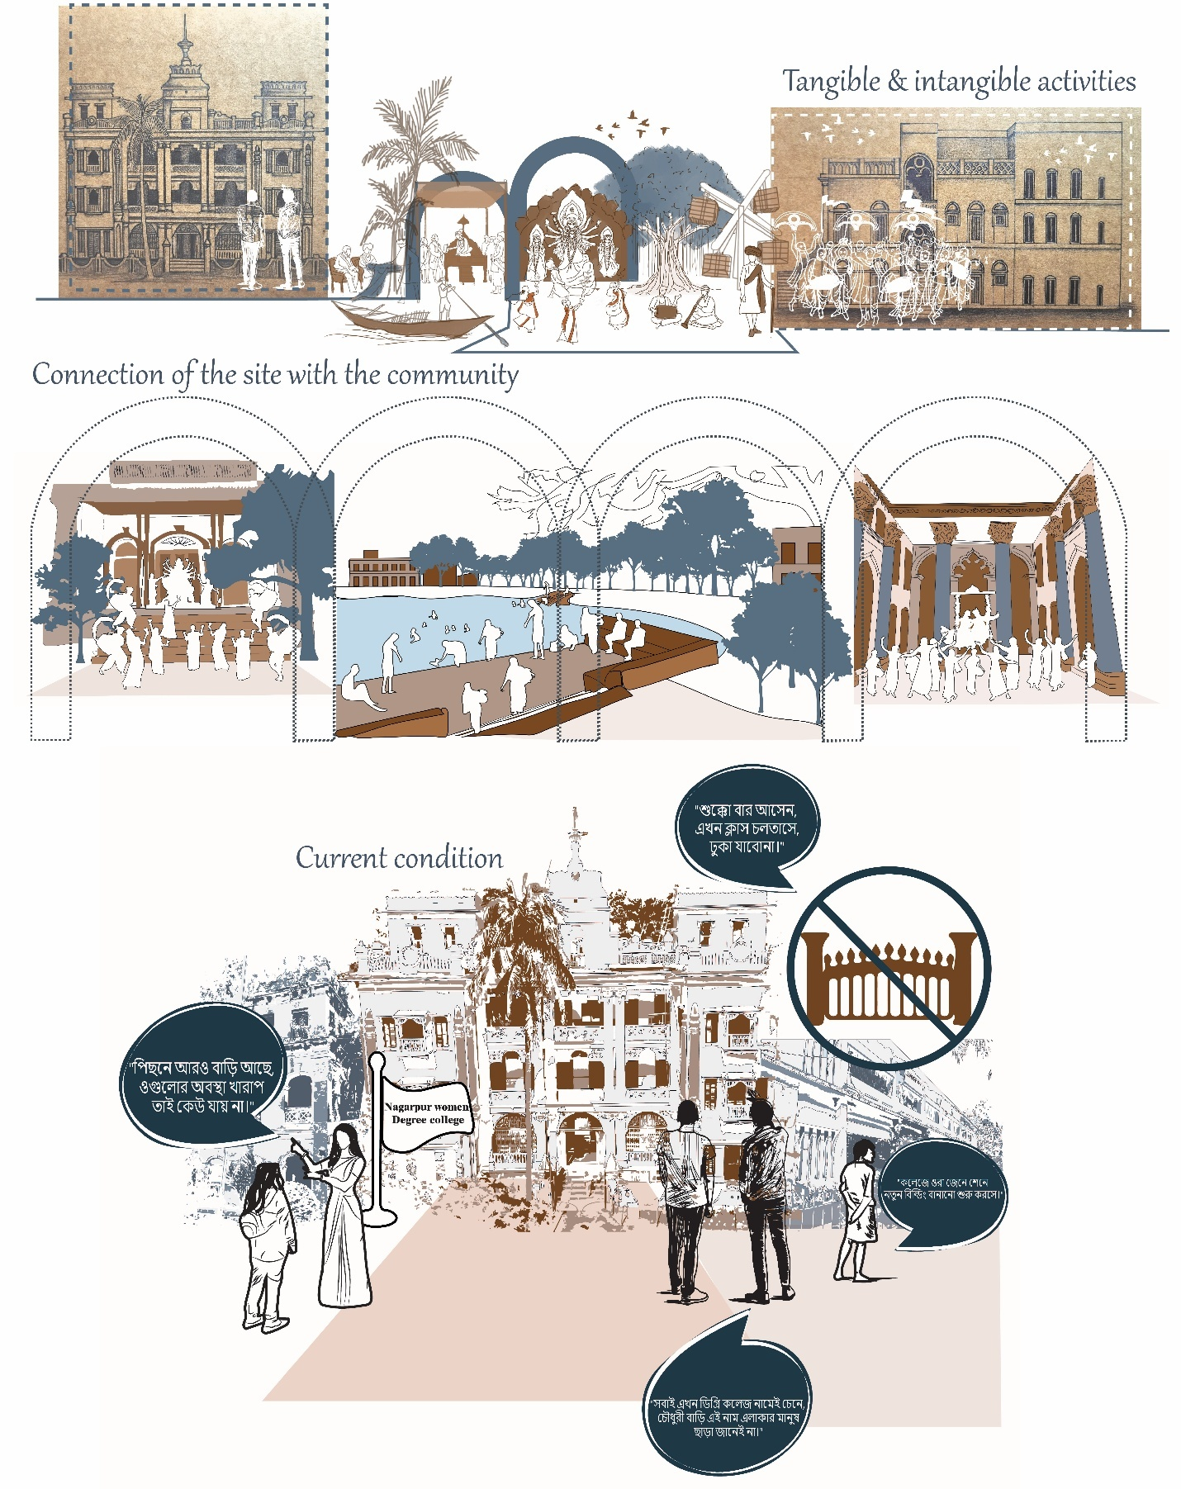
Conceptual diagrams

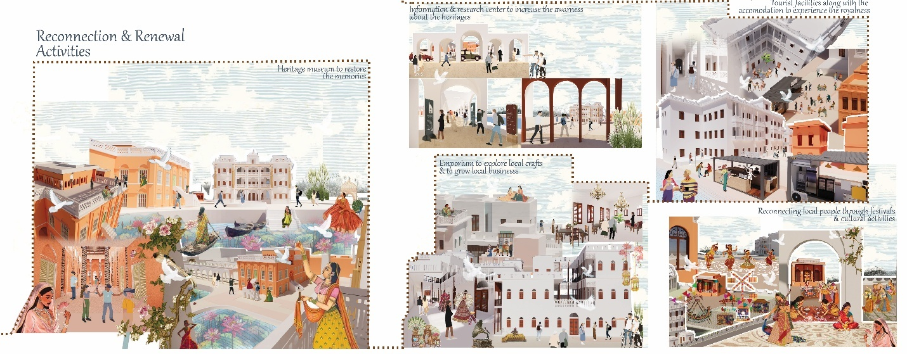
Key activities diagrams

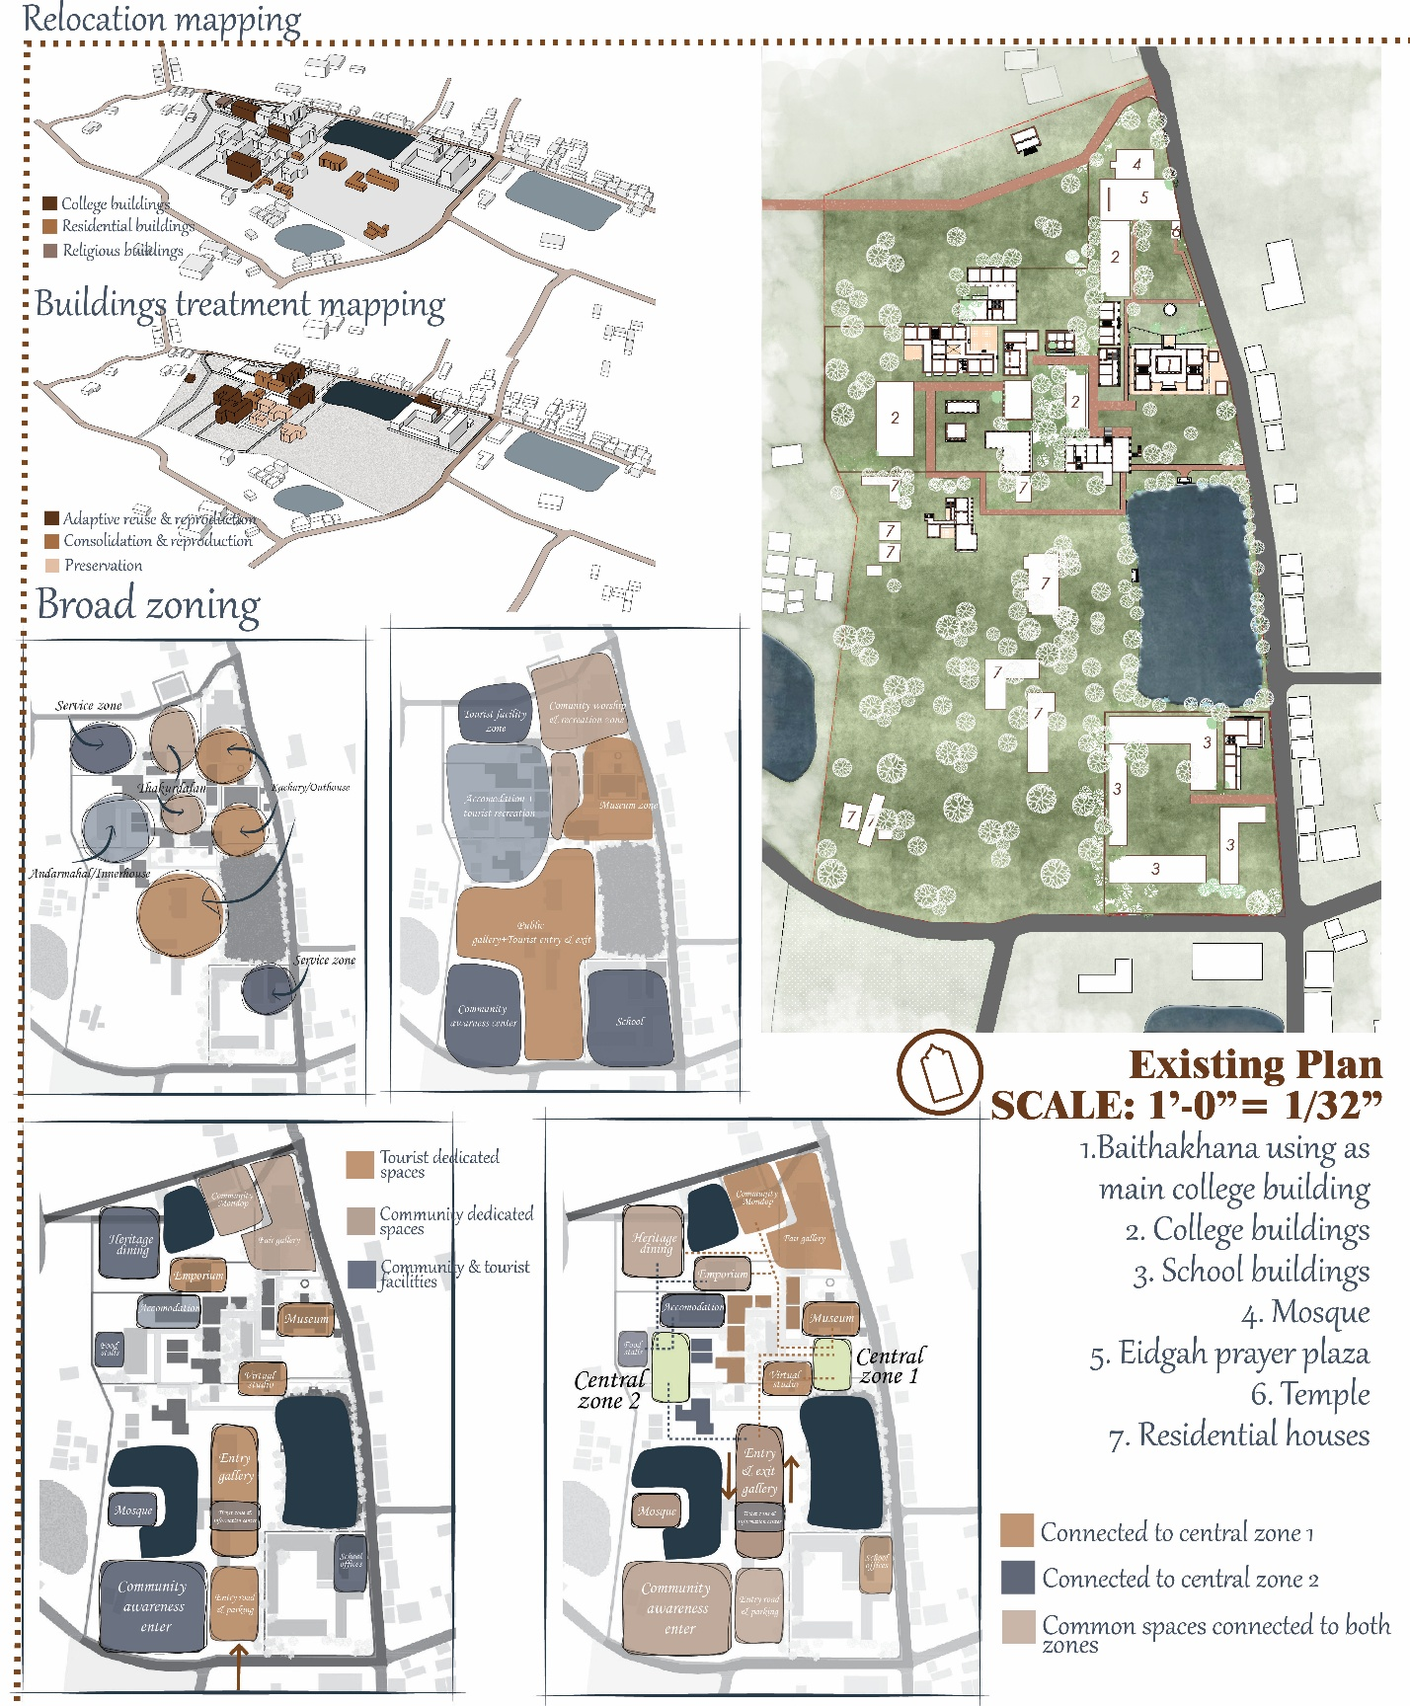
Broad zoning & existing plan

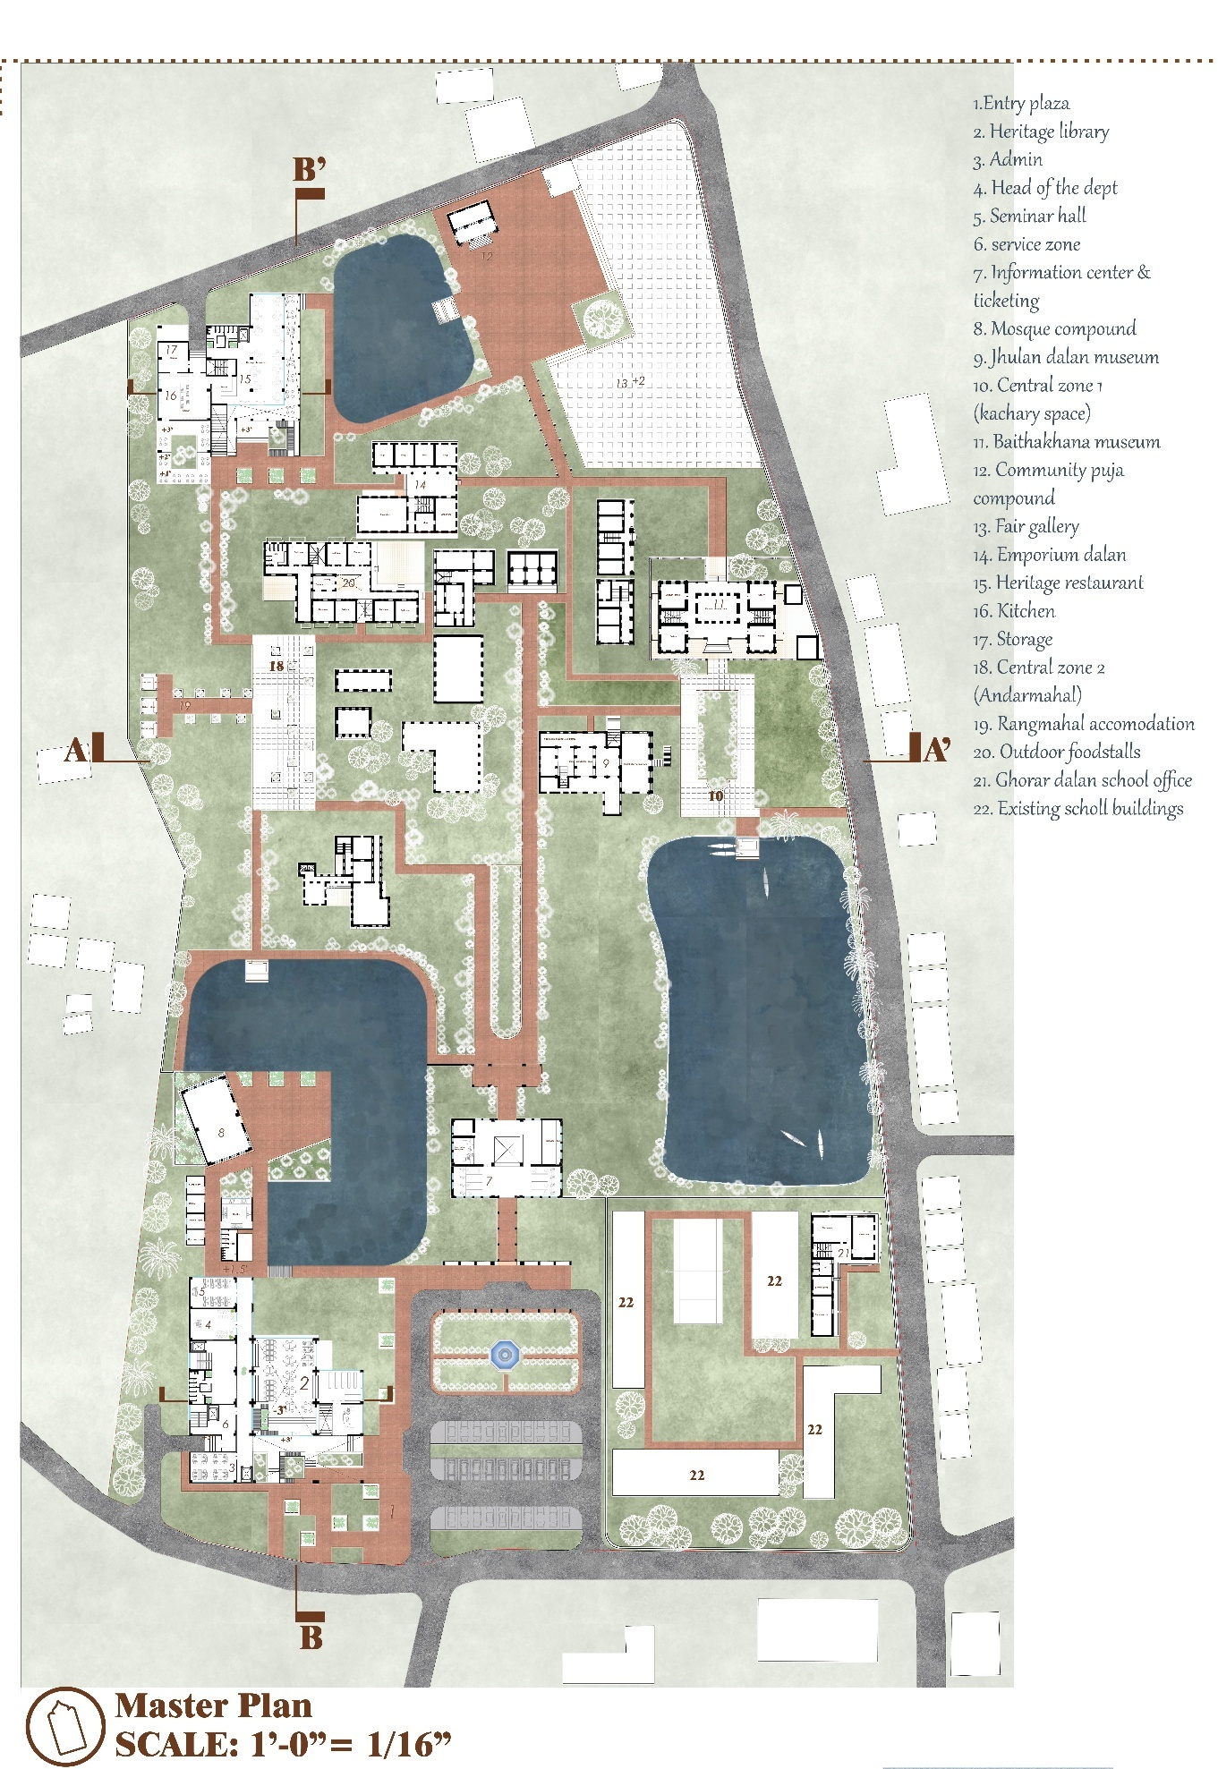
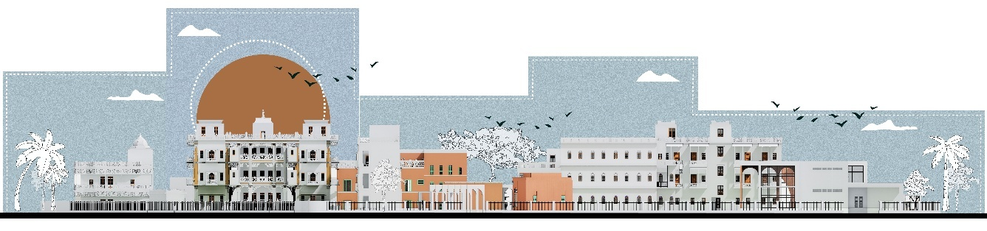
NORTH ELEVATION
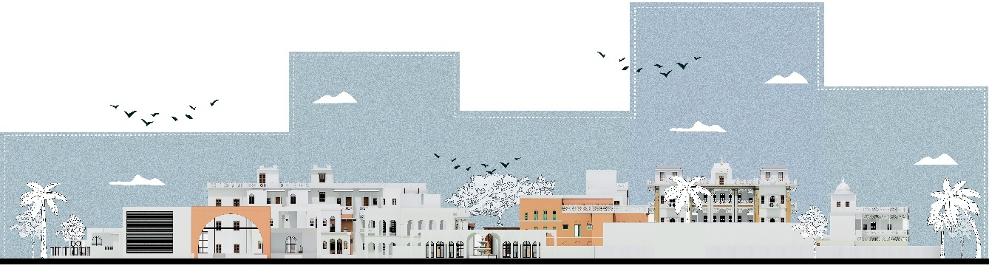
SOUTH ELEVATION
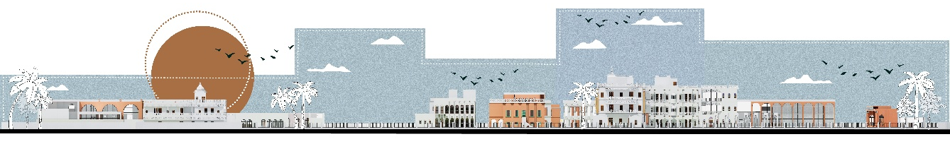
EAST ELEVATION

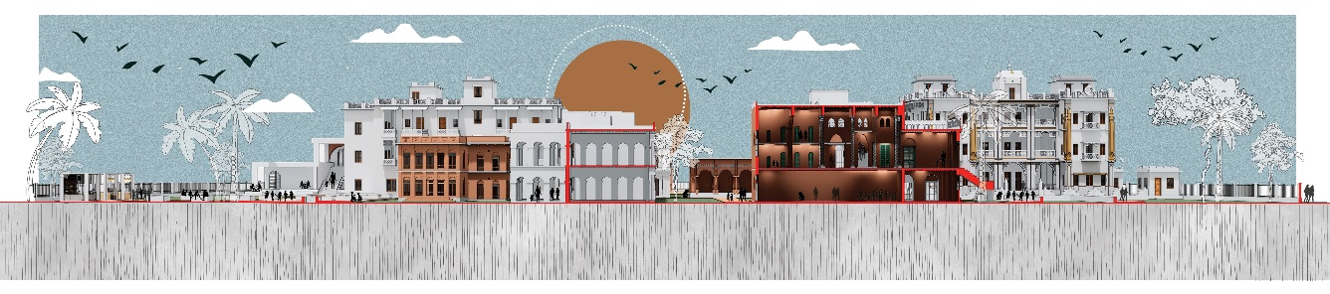
SECTION AA’

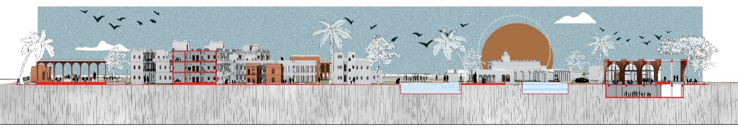
SECTION BB’

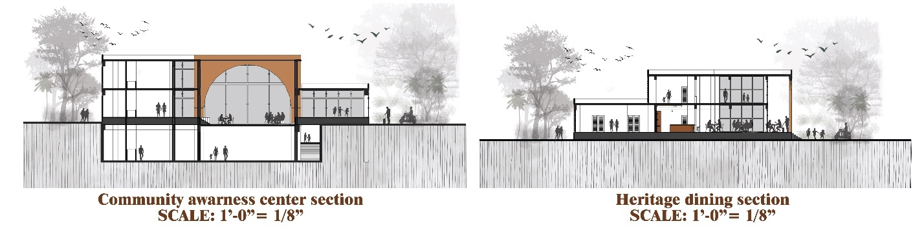

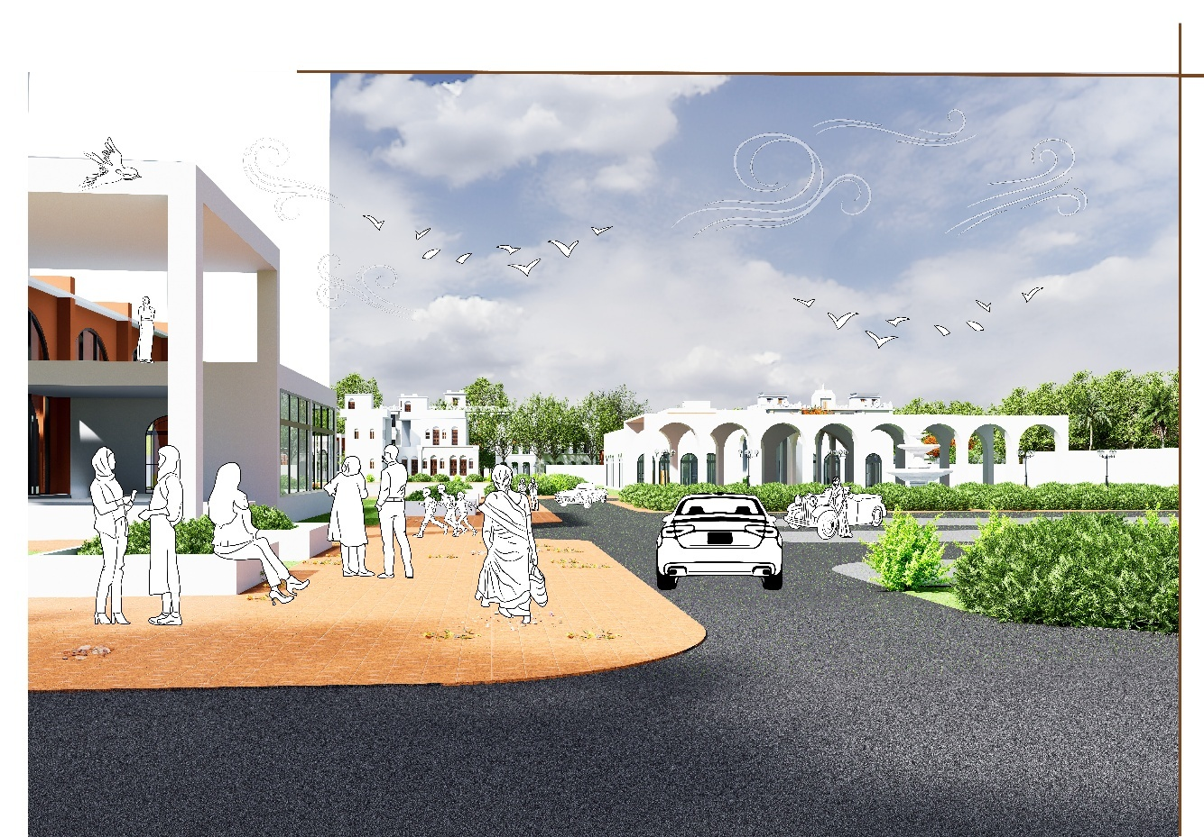
Vehicular and plaza entry
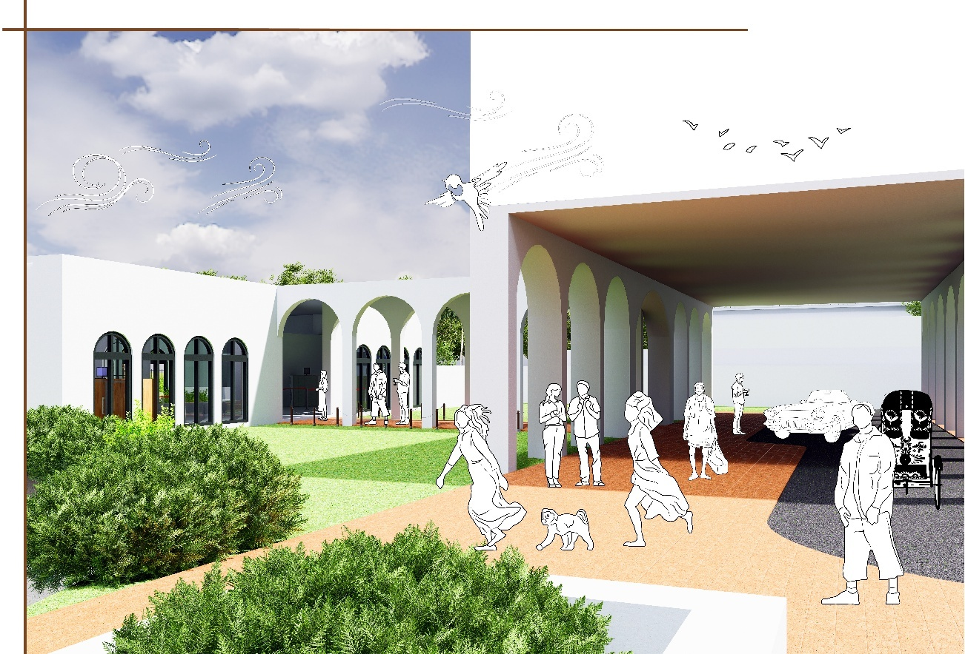
Portico drop off
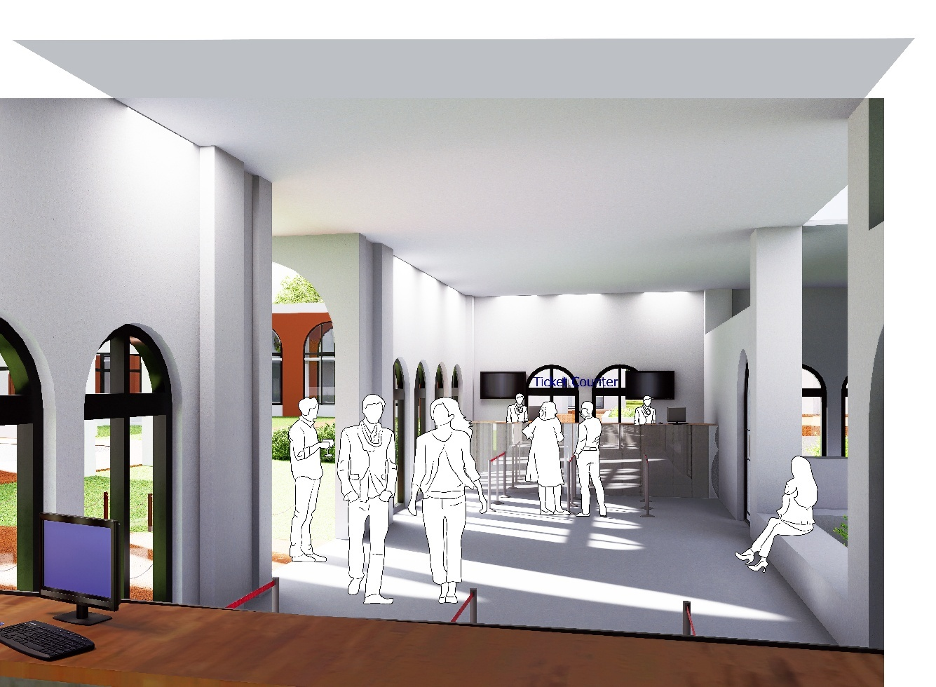
Ticket lobby and information center
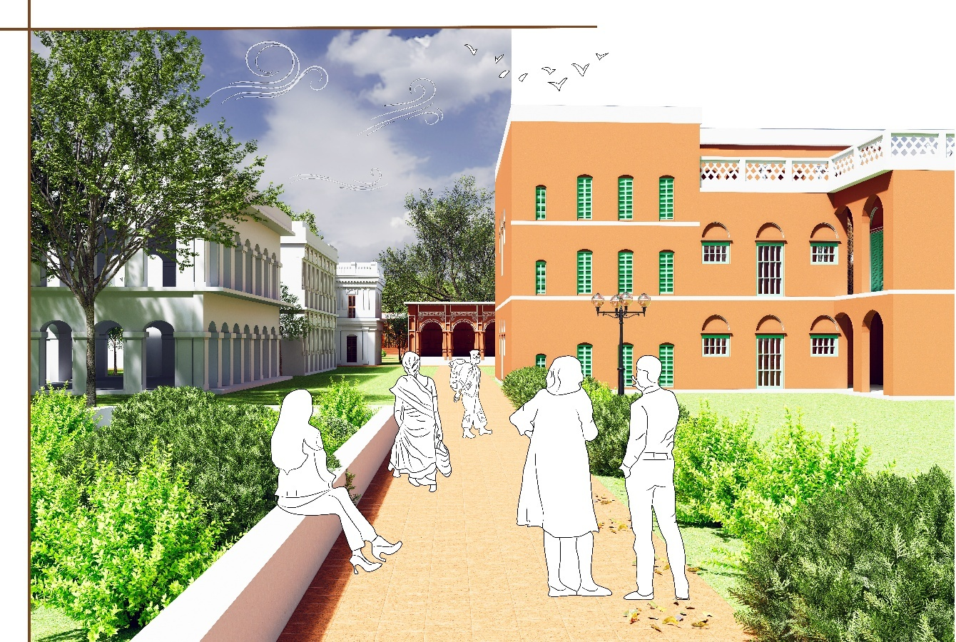
Entry to thakurdalan

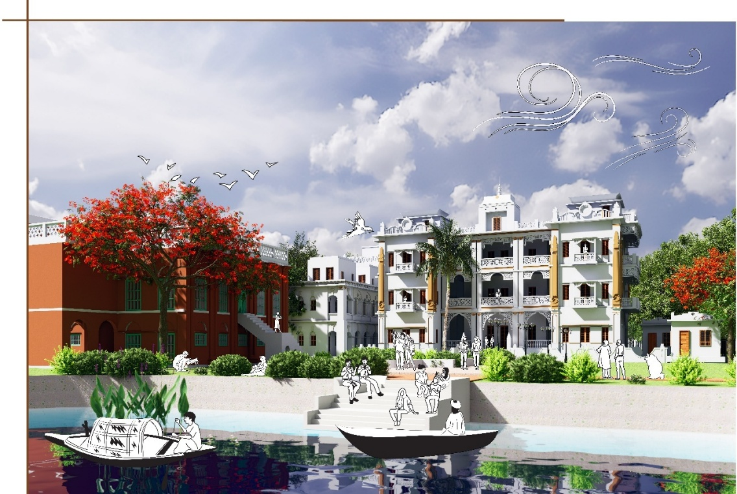
Central zone 1: Museum gallery/ kachary
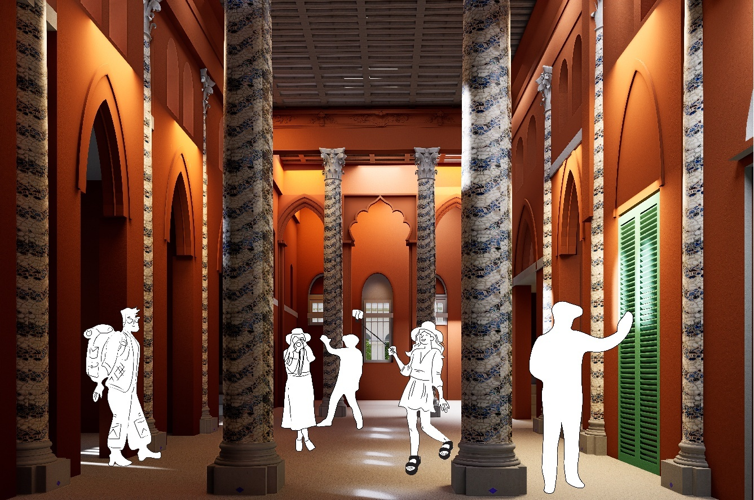
Jhulan dalan VR experience
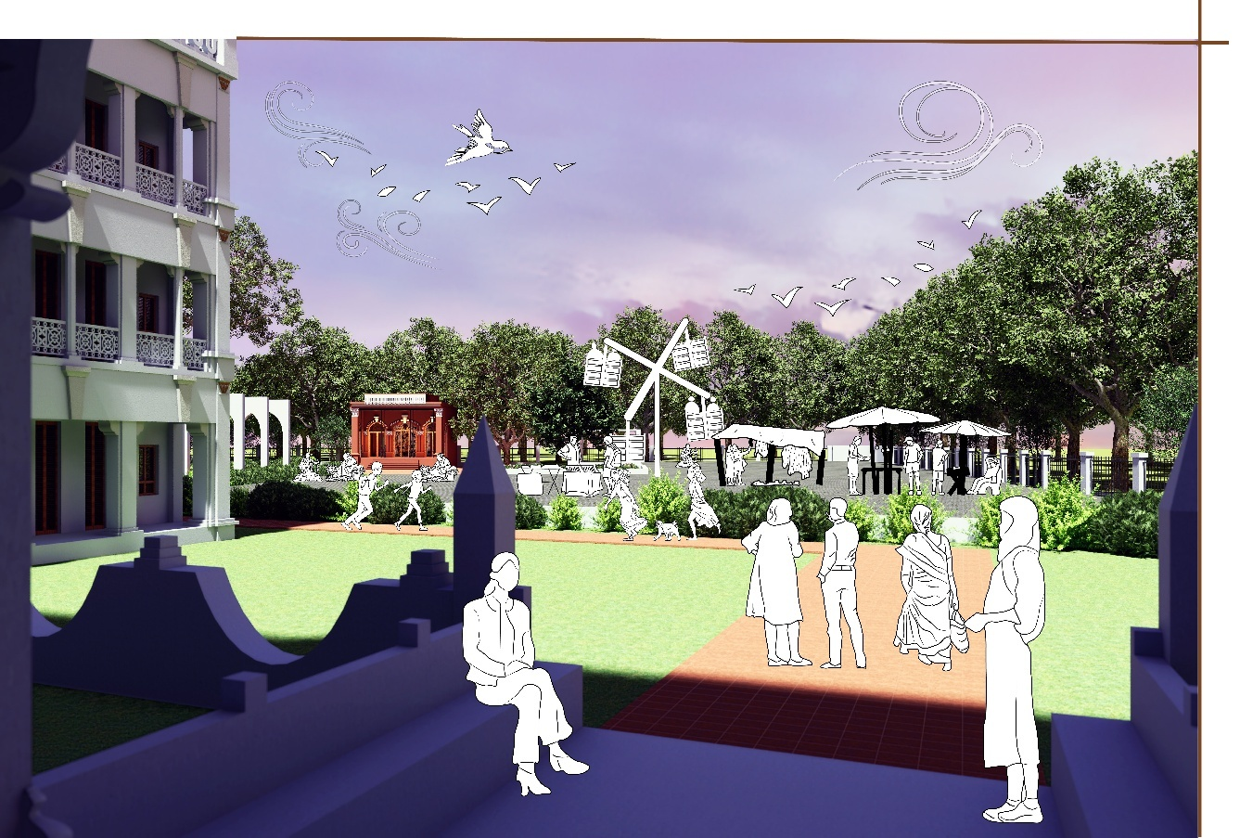
View of Fair gallery from the exit of Baithak khana
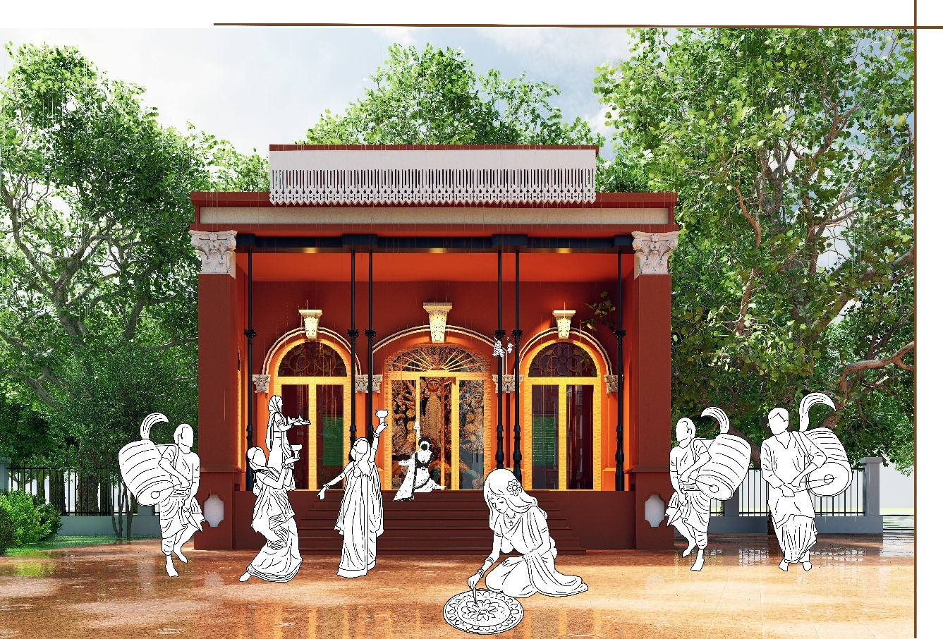
Community thakurdalan celebrating festivals
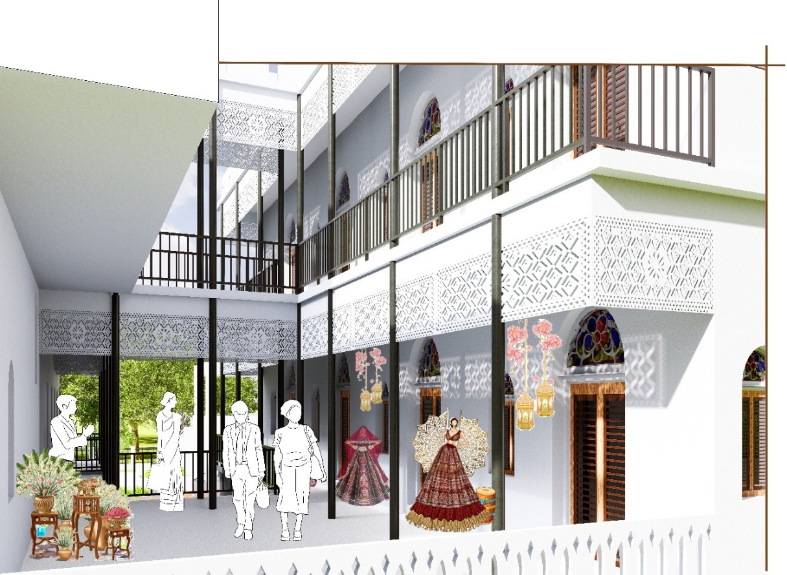
Emporium for exploring local crafts

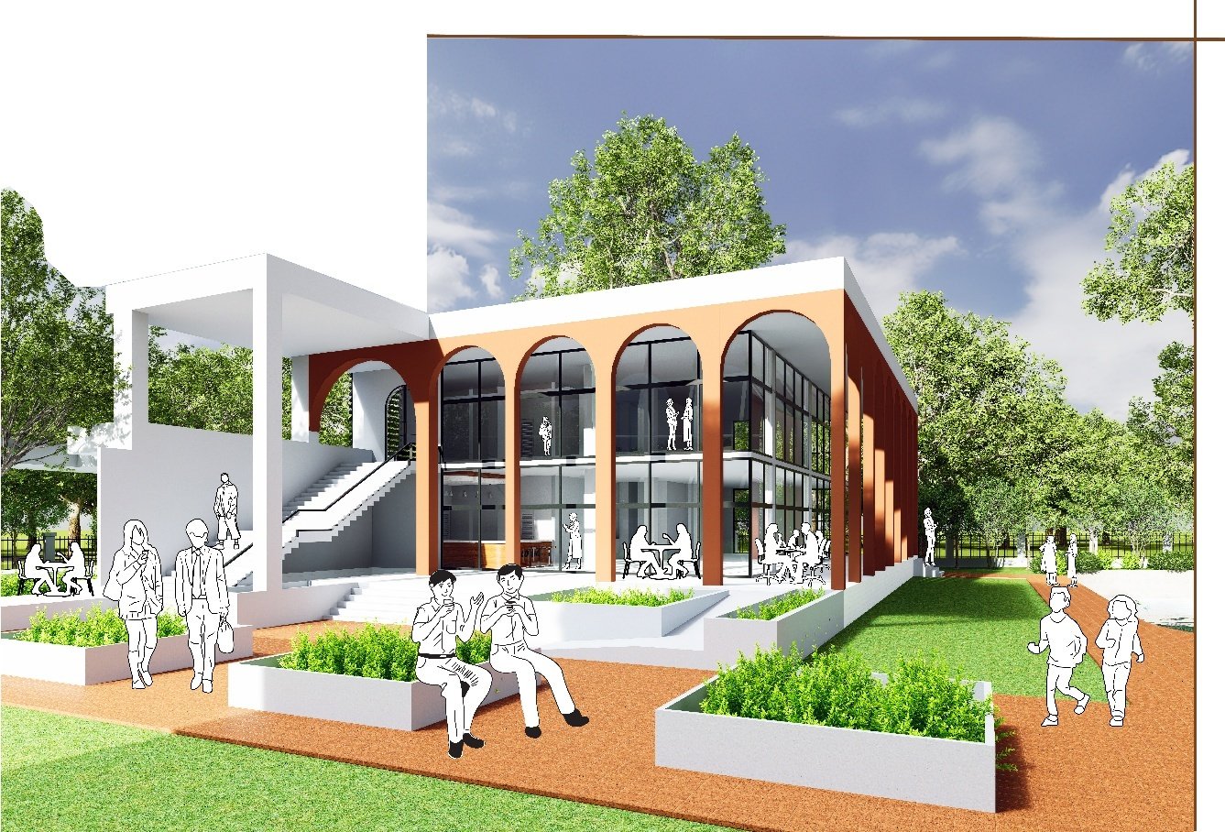
Entry plaza of restaurant
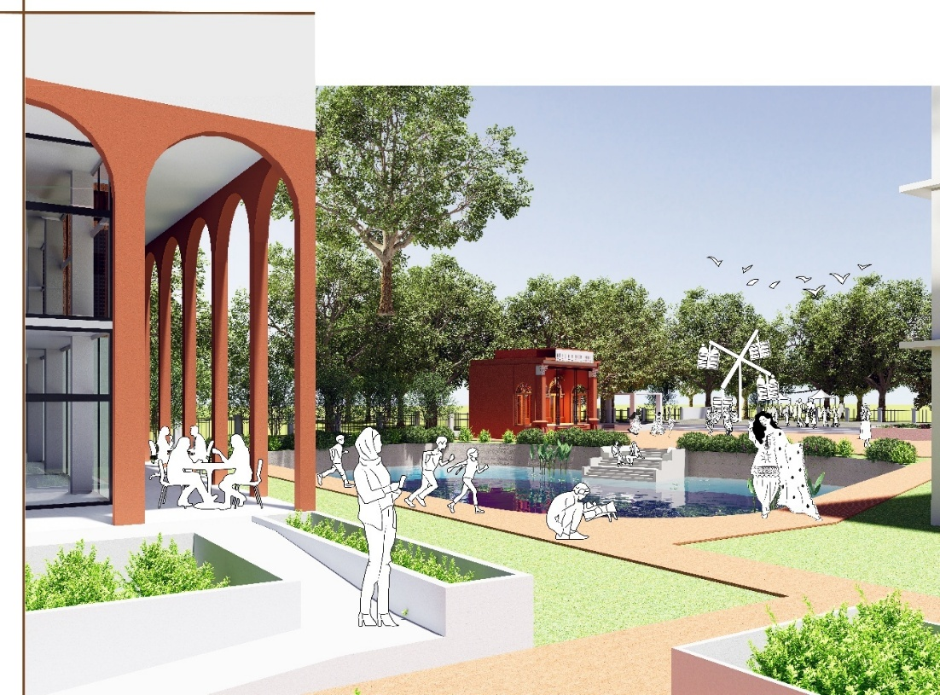
View of community thakurdalan & fair gallery from restaurant
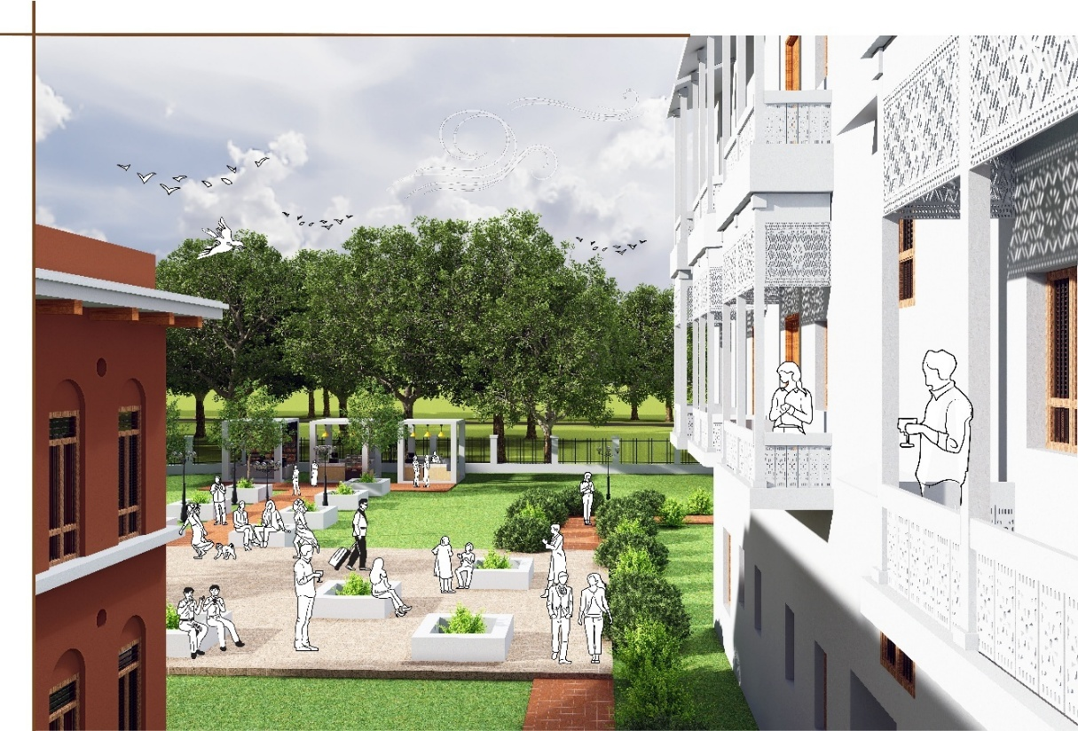
Central zone 2/ Andarmahal
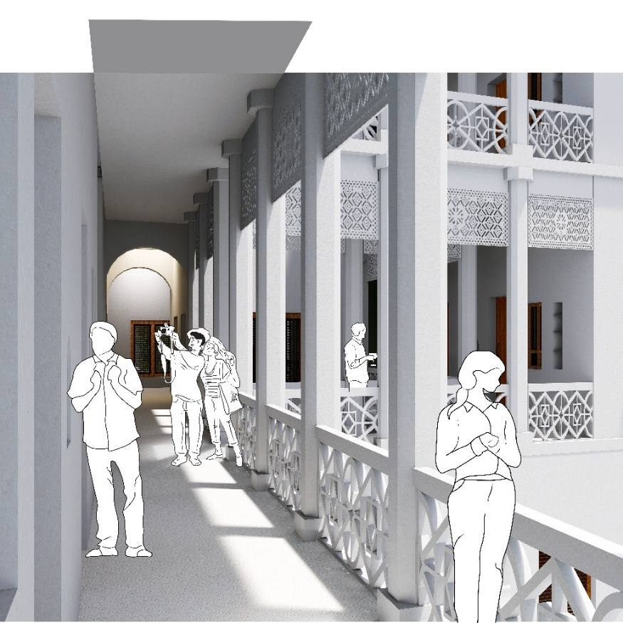
Accomodation in Rangmahal
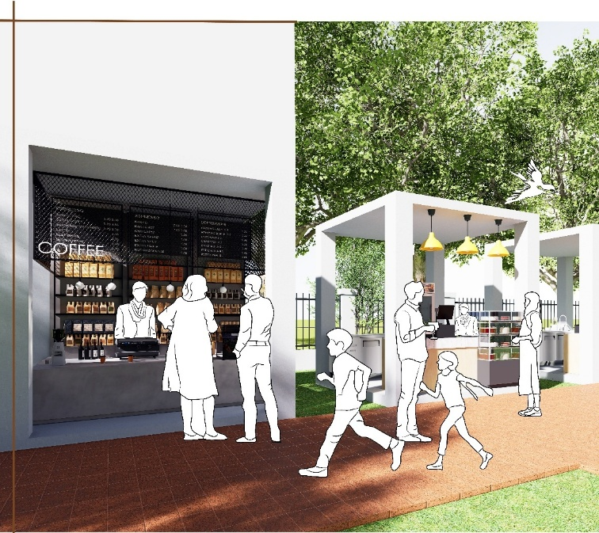
Food stalls at central zone 2
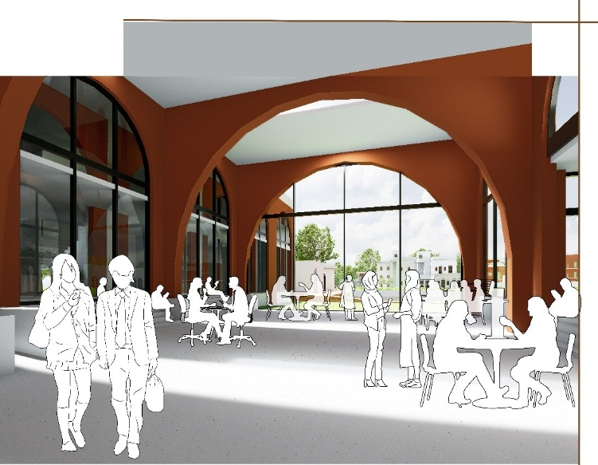
Sunken heritage library
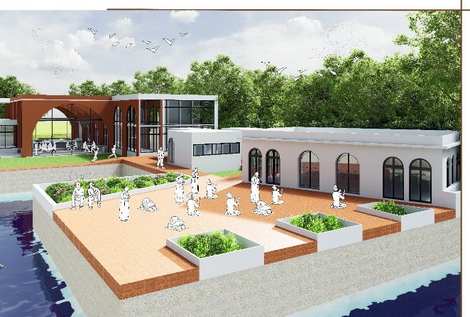
Mosque gallery
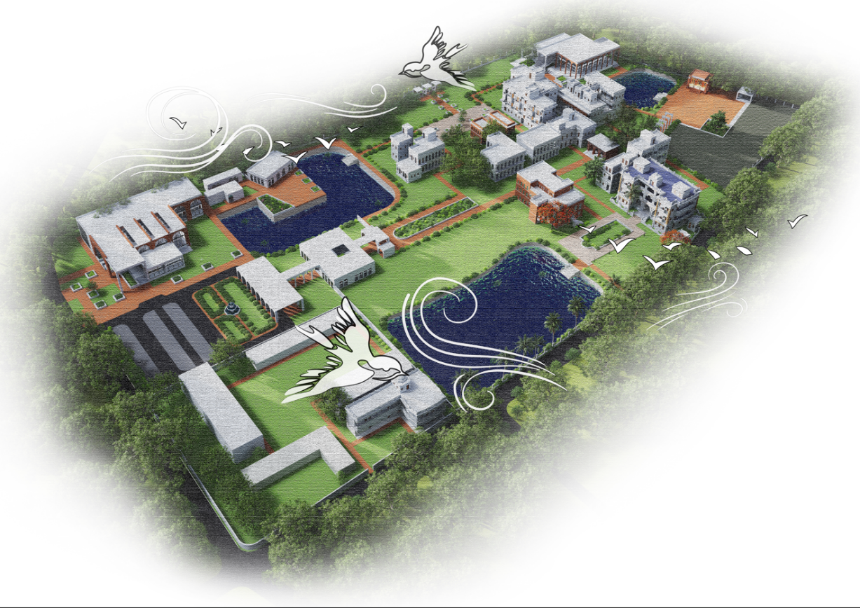
Bird’s eye view

Name: Shayni Saha
Email: shaynisaha7@gmail.com
Social media link: https://www.facebook.com/shaynisaha42?mibextid=ZbWKwL

